**ONLINE BOOKSTORE DATABASE MANAGEMENT SYSTEM**

**Name:** Nancy Jemimah Packiyanathan

**NUID:** 001475975

**PROBLEM STATEMENT:**

The objective of this project is to develop an e- book store where books can be bought from the comfort of home through the Internet.

An online book store is a virtual store on the Internet where customers can browse the

catalog and select books of interest. The selected books may be collected in a shopping cart. At checkout time, the items in the shopping cart will be presented as an order. At that time, more information will be needed to complete the transaction.Usually, the customer will be asked to fill or select a billing address, a shipping address, a shipping option, and payment information such as credit card number.

I have used triggers, stored procedure and views to make it easy for the admin and the customers to view their records.

**Entity- Relationship Diagram;**

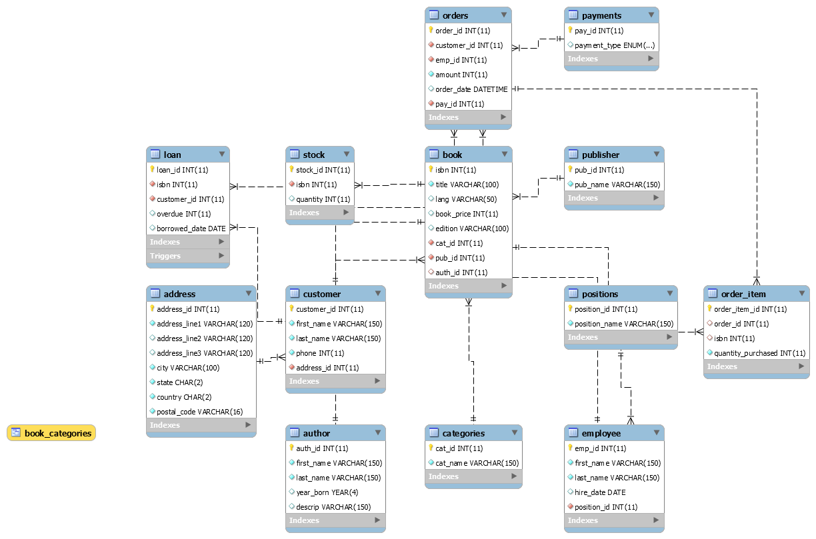

**View to see the book, author, category, publisher records;**

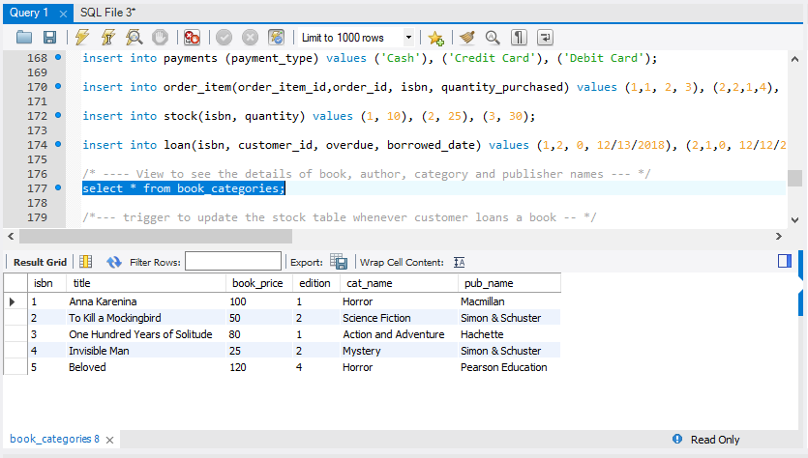

**Trigger to update the stock table whenever customer loans a book**

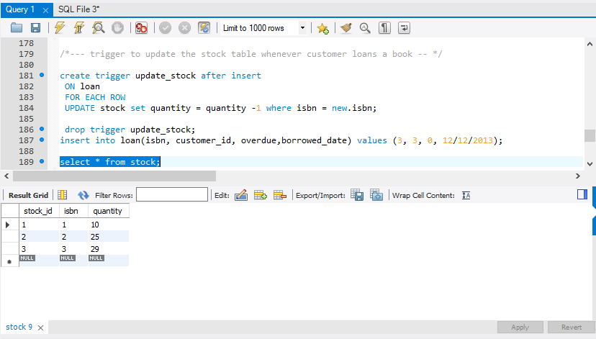

**Trigger to delete row whenever the book is returned**

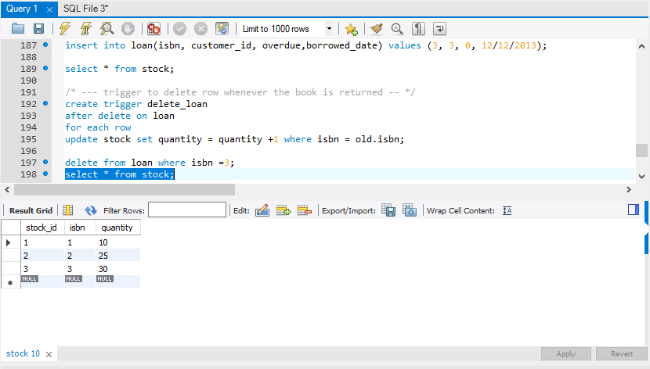

**Stored procedure to find out how many orders the particular employee has done**

Employee_id had sold 2 orders

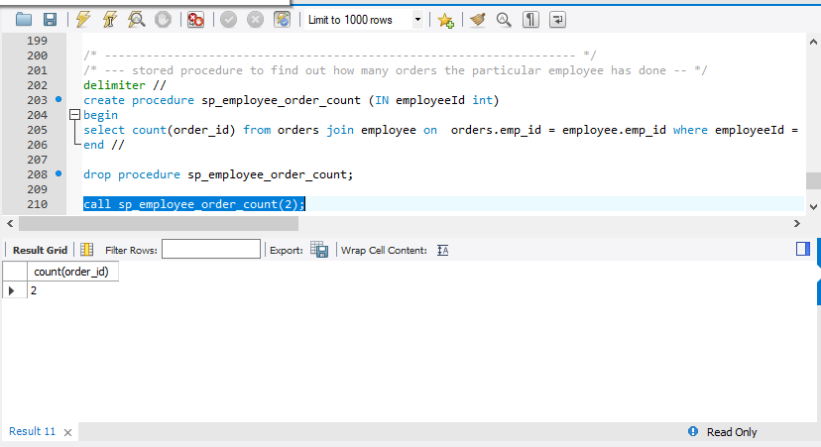

**Creating User Privileges for the admin so that he can access the orders table and provide employee hike:**

create user 'jemimah'@'localhost' identified by 'jemimah';

grant all on bookstore.* to 'jemimah'@'localhost';

grant select on bookstore.orders TO 'jemimah'@'localhost';

**User Defined Function to calculate the creditlimit of the customer:**

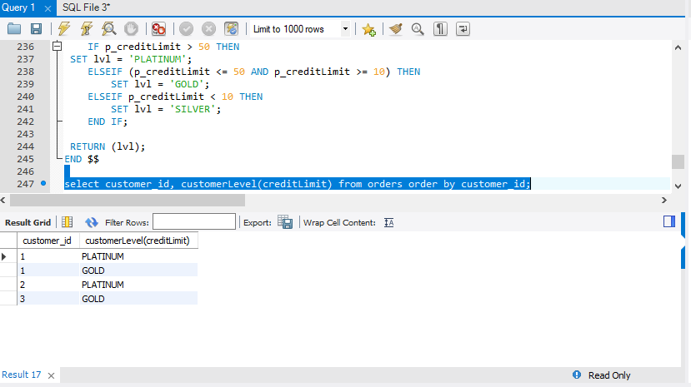

**APPENDIX**

-- MySQL dump 10.13 Distrib 8.0.12, for Win64 (x86_64)

--

-- Host: localhost Database: bookstore

-- ------------------------------------------------------

-- Server version 8.0.12

/*!40101 SET @OLD_CHARACTER_SET_CLIENT=@@CHARACTER_SET_CLIENT */;

/*!40101 SET @OLD_CHARACTER_SET_RESULTS=@@CHARACTER_SET_RESULTS */;

/*!40101 SET @OLD_COLLATION_CONNECTION=@@COLLATION_CONNECTION */;

SET NAMES utf8mb4 ;

/*!40103 SET @OLD_TIME_ZONE=@@TIME_ZONE */;

/*!40103 SET TIME_ZONE='+00:00' */;

/*!40014 SET @OLD_UNIQUE_CHECKS=@@UNIQUE_CHECKS, UNIQUE_CHECKS=0 */;

/*!40014 SET @OLD_FOREIGN_KEY_CHECKS=@@FOREIGN_KEY_CHECKS, FOREIGN_KEY_CHECKS=0 */;

/*!40101 SET @OLD_SQL_MODE=@@SQL_MODE, SQL_MODE='NO_AUTO_VALUE_ON_ZERO' */;

/*!40111 SET @OLD_SQL_NOTES=@@SQL_NOTES, SQL_NOTES=0 */;

--

-- Table structure for table `address`

--

DROP TABLE IF EXISTS `address`;

/*!40101 SET @saved_cs_client = @@character_set_client */;

SET character_set_client = utf8mb4 ;

CREATE TABLE `address` (

`address_id` int(11) NOT NULL AUTO_INCREMENT,

`address_line1` varchar(120) NOT NULL,

`address_line2` varchar(120) DEFAULT NULL,

`address_line3` varchar(120) DEFAULT NULL,

`city` varchar(100) NOT NULL,

`state` char(2) NOT NULL,

`country` char(2) NOT NULL,

`postal_code` varchar(16) NOT NULL,

PRIMARY KEY (`address_id`)

) ENGINE=InnoDB AUTO_INCREMENT=6 DEFAULT CHARSET=utf8mb4 COLLATE=utf8mb4_0900_ai_ci;

/*!40101 SET character_set_client = @saved_cs_client */;

--

-- Dumping data for table `address`

--

LOCK TABLES `address` WRITE;

/*!40000 ALTER TABLE `address` DISABLE KEYS */;

INSERT INTO `address` VALUES (1,'Mission Main','Roxbury Crossing',NULL,'Boston','MA','US','2120'),(2,'City View','Tremont Street',NULL,'Boston','MA','US','2125'),(3,'St Germain Street','Common Wealth Avenue',NULL,'Boston','MA','US','2126'),(4,'Beau Jardin',NULL,NULL,'Indianapolis','IN','US','2128'),(5,'Mass Avenue',NULL,NULL,'Boston','MA','US','2122');

/*!40000 ALTER TABLE `address` ENABLE KEYS */;

UNLOCK TABLES;

--

-- Table structure for table `author`

--

DROP TABLE IF EXISTS `author`;

/*!40101 SET @saved_cs_client = @@character_set_client */;

SET character_set_client = utf8mb4 ;

CREATE TABLE `author` (

`auth_id` int(11) NOT NULL AUTO_INCREMENT,

`first_name` varchar(150) NOT NULL,

`last_name` varchar(150) NOT NULL,

`year_born` year(4) DEFAULT NULL,

`descrip` varchar(150) DEFAULT NULL,

PRIMARY KEY (`auth_id`)

) ENGINE=InnoDB AUTO_INCREMENT=6 DEFAULT CHARSET=utf8mb4 COLLATE=utf8mb4_0900_ai_ci;

/*!40101 SET character_set_client = @saved_cs_client */;

--

-- Dumping data for table `author`

--

LOCK TABLES `author` WRITE;

/*!40000 ALTER TABLE `author` DISABLE KEYS */;

INSERT INTO `author` VALUES (1,'Bernard','Waber',1985,'Book to remember'),(2,'Tad','Waddington',1980,'Remembering the journey'),(3,'Roland','Wagner',1990,'Dedicated to my parents'),(4,'Alice','Walker',1996,'To my beloved friends'),(5,'Ian','Wallace',1978,'To all my people');

/*!40000 ALTER TABLE `author` ENABLE KEYS */;

UNLOCK TABLES;

--

-- Table structure for table `book`

--

DROP TABLE IF EXISTS `book`;

/*!40101 SET @saved_cs_client = @@character_set_client */;

SET character_set_client = utf8mb4 ;

CREATE TABLE `book` (

`isbn` int(11) NOT NULL AUTO_INCREMENT,

`title` varchar(100) NOT NULL,

`lang` varchar(50) DEFAULT NULL,

`book_price` int(11) DEFAULT NULL,

`edition` varchar(100) DEFAULT NULL,

`cat_id` int(11) NOT NULL,

`pub_id` int(11) NOT NULL,

`auth_id` int(11) DEFAULT NULL,

PRIMARY KEY (`isbn`),

KEY `fk_cat` (`cat_id`),

KEY `fk_pub` (`pub_id`),

KEY `auth_id` (`auth_id`),

CONSTRAINT `book_ibfk_1` FOREIGN KEY (`auth_id`) REFERENCES `author` (`auth_id`) ON DELETE CASCADE,

CONSTRAINT `fk_cat` FOREIGN KEY (`cat_id`) REFERENCES `categories` (`cat_id`) ON DELETE CASCADE,

CONSTRAINT `fk_pub` FOREIGN KEY (`pub_id`) REFERENCES `publisher` (`pub_id`) ON DELETE CASCADE

) ENGINE=InnoDB AUTO_INCREMENT=6 DEFAULT CHARSET=utf8mb4 COLLATE=utf8mb4_0900_ai_ci;

/*!40101 SET character_set_client = @saved_cs_client */;

--

-- Dumping data for table `book`

--

LOCK TABLES `book` WRITE;

/*!40000 ALTER TABLE `book` DISABLE KEYS */;

INSERT INTO `book` VALUES (1,'Anna Karenina','EN',100,'1',2,1,2),(2,'To Kill a Mockingbird','ES',50,'2',1,3,1),(3,'One Hundred Years of Solitude','EN',80,'1',3,4,3),(4,'Invisible Man','EN',25,'2',5,3,4),(5,'Beloved','ES',120,'4',2,5,5);

/*!40000 ALTER TABLE `book` ENABLE KEYS */;

UNLOCK TABLES;

--

-- Temporary view structure for view `book_categories`

--

DROP TABLE IF EXISTS `book_categories`;

/*!50001 DROP VIEW IF EXISTS `book_categories`*/;

SET @saved_cs_client = @@character_set_client;

SET character_set_client = utf8mb4;

/*!50001 CREATE VIEW `book_categories` AS SELECT

1 AS `isbn`,

1 AS `title`,

1 AS `book_price`,

1 AS `edition`,

1 AS `cat_name`,

1 AS `pub_name`*/;

SET character_set_client = @saved_cs_client;

--

-- Table structure for table `categories`

--

DROP TABLE IF EXISTS `categories`;

/*!40101 SET @saved_cs_client = @@character_set_client */;

SET character_set_client = utf8mb4 ;

CREATE TABLE `categories` (

`cat_id` int(11) NOT NULL AUTO_INCREMENT,

`cat_name` varchar(150) NOT NULL,

PRIMARY KEY (`cat_id`)

) ENGINE=InnoDB AUTO_INCREMENT=6 DEFAULT CHARSET=utf8mb4 COLLATE=utf8mb4_0900_ai_ci;

/*!40101 SET character_set_client = @saved_cs_client */;

--

-- Dumping data for table `categories`

--

LOCK TABLES `categories` WRITE;

/*!40000 ALTER TABLE `categories` DISABLE KEYS */;

INSERT INTO `categories` VALUES (1,'Science Fiction'),(2,'Horror'),(3,'Action and Adventure'),(4,'Self Help'),(5,'Mystery');

/*!40000 ALTER TABLE `categories` ENABLE KEYS */;

UNLOCK TABLES;

--

-- Table structure for table `customer`

--

DROP TABLE IF EXISTS `customer`;

/*!40101 SET @saved_cs_client = @@character_set_client */;

SET character_set_client = utf8mb4 ;

CREATE TABLE `customer` (

`customer_id` int(11) NOT NULL AUTO_INCREMENT,

`first_name` varchar(150) NOT NULL,

`last_name` varchar(150) NOT NULL,

`phone` int(11) NOT NULL,

`address_id` int(11) NOT NULL,

PRIMARY KEY (`customer_id`),

KEY `fk_customer_address` (`address_id`),

CONSTRAINT `fk_customer_address` FOREIGN KEY (`address_id`) REFERENCES `address` (`address_id`) ON DELETE CASCADE

) ENGINE=InnoDB AUTO_INCREMENT=6 DEFAULT CHARSET=utf8mb4 COLLATE=utf8mb4_0900_ai_ci;

/*!40101 SET character_set_client = @saved_cs_client */;

--

-- Dumping data for table `customer`

--

LOCK TABLES `customer` WRITE;

/*!40000 ALTER TABLE `customer` DISABLE KEYS */;

INSERT INTO `customer` VALUES (1,'Nancy','Jemimah',857352870,1),(2,'Srinivasa','Rao',857764892,3),(3,'Aphurvikaa','Mani',234567890,2),(4,'Niranjana','Shree',123567843,4),(5,'Nandhu','Chandru',944312520,5);

/*!40000 ALTER TABLE `customer` ENABLE KEYS */;

UNLOCK TABLES;

--

-- Table structure for table `employee`

--

DROP TABLE IF EXISTS `employee`;

/*!40101 SET @saved_cs_client = @@character_set_client */;

SET character_set_client = utf8mb4 ;

CREATE TABLE `employee` (

`emp_id` int(11) NOT NULL AUTO_INCREMENT,

`first_name` varchar(150) NOT NULL,

`last_name` varchar(150) NOT NULL,

`hire_date` date DEFAULT NULL,

`position_id` int(11) NOT NULL,

PRIMARY KEY (`emp_id`),

KEY `fk_emp_position` (`position_id`),

CONSTRAINT `fk_emp_position` FOREIGN KEY (`position_id`) REFERENCES `positions` (`position_id`) ON DELETE CASCADE

) ENGINE=InnoDB AUTO_INCREMENT=4 DEFAULT CHARSET=utf8mb4 COLLATE=utf8mb4_0900_ai_ci;

/*!40101 SET character_set_client = @saved_cs_client */;

--

-- Dumping data for table `employee`

--

LOCK TABLES `employee` WRITE;

/*!40000 ALTER TABLE `employee` DISABLE KEYS */;

INSERT INTO `employee` VALUES (1,'Packiyanathan','D','0000-00-00',1),(2,'Jasmine','P','0000-00-00',2),(3,'Stanley','Johnson','0000-00-00',3);

/*!40000 ALTER TABLE `employee` ENABLE KEYS */;

UNLOCK TABLES;

--

-- Table structure for table `loan`

--

DROP TABLE IF EXISTS `loan`;

/*!40101 SET @saved_cs_client = @@character_set_client */;

SET character_set_client = utf8mb4 ;

CREATE TABLE `loan` (

`loan_id` int(11) NOT NULL AUTO_INCREMENT,

`isbn` int(11) NOT NULL,

`customer_id` int(11) NOT NULL,

`overdue` int(11) DEFAULT NULL,

`borrowed_date` date DEFAULT NULL,

PRIMARY KEY (`loan_id`),

KEY `fk_loan_book` (`isbn`),

KEY `fk_loan_customer` (`customer_id`),

CONSTRAINT `fk_loan_book` FOREIGN KEY (`isbn`) REFERENCES `book` (`isbn`) ON DELETE CASCADE,

CONSTRAINT `fk_loan_customer` FOREIGN KEY (`customer_id`) REFERENCES `customer` (`customer_id`) ON DELETE CASCADE

) ENGINE=InnoDB AUTO_INCREMENT=7 DEFAULT CHARSET=utf8mb4 COLLATE=utf8mb4_0900_ai_ci;

/*!40101 SET character_set_client = @saved_cs_client */;

--

-- Dumping data for table `loan`

--

LOCK TABLES `loan` WRITE;

/*!40000 ALTER TABLE `loan` DISABLE KEYS */;

INSERT INTO `loan` VALUES (1,1,2,0,'0000-00-00'),(2,2,1,0,'0000-00-00');

/*!40000 ALTER TABLE `loan` ENABLE KEYS */;

UNLOCK TABLES;

/*!50003 SET @saved_cs_client = @@character_set_client */ ;

/*!50003 SET @saved_cs_results = @@character_set_results */ ;

/*!50003 SET @saved_col_connection = @@collation_connection */ ;

/*!50003 SET character_set_client = utf8mb4 */ ;

/*!50003 SET character_set_results = utf8mb4 */ ;

/*!50003 SET collation_connection = utf8mb4_0900_ai_ci */ ;

/*!50003 SET @saved_sql_mode = @@sql_mode */ ;

/*!50003 SET sql_mode = 'STRICT_TRANS_TABLES,NO_ENGINE_SUBSTITUTION' */ ;

DELIMITER ;;

/*!50003 CREATE*/ /*!50017 DEFINER=`root`@`localhost`*/ /*!50003 TRIGGER `update_stock` AFTER INSERT ON `loan` FOR EACH ROW UPDATE stock set quantity = quantity -1 where isbn = new.isbn */;;

DELIMITER ;

/*!50003 SET sql_mode = @saved_sql_mode */ ;

/*!50003 SET character_set_client = @saved_cs_client */ ;

/*!50003 SET character_set_results = @saved_cs_results */ ;

/*!50003 SET collation_connection = @saved_col_connection */ ;

/*!50003 SET @saved_cs_client = @@character_set_client */ ;

/*!50003 SET @saved_cs_results = @@character_set_results */ ;

/*!50003 SET @saved_col_connection = @@collation_connection */ ;

/*!50003 SET character_set_client = utf8mb4 */ ;

/*!50003 SET character_set_results = utf8mb4 */ ;

/*!50003 SET collation_connection = utf8mb4_0900_ai_ci */ ;

/*!50003 SET @saved_sql_mode = @@sql_mode */ ;

/*!50003 SET sql_mode = 'STRICT_TRANS_TABLES,NO_ENGINE_SUBSTITUTION' */ ;

DELIMITER ;;

/*!50003 CREATE*/ /*!50017 DEFINER=`root`@`localhost`*/ /*!50003 TRIGGER `delete_loan` AFTER DELETE ON `loan` FOR EACH ROW update stock set quantity = quantity +1 where isbn = old.isbn */;;

DELIMITER ;

/*!50003 SET sql_mode = @saved_sql_mode */ ;

/*!50003 SET character_set_client = @saved_cs_client */ ;

/*!50003 SET character_set_results = @saved_cs_results */ ;

/*!50003 SET collation_connection = @saved_col_connection */ ;

--

-- Table structure for table `order_item`

--

DROP TABLE IF EXISTS `order_item`;

/*!40101 SET @saved_cs_client = @@character_set_client */;

SET character_set_client = utf8mb4 ;

CREATE TABLE `order_item` (

`order_item_id` int(11) NOT NULL,

`order_id` int(11) DEFAULT NULL,

`isbn` int(11) DEFAULT NULL,

`quantity_purchased` int(11) NOT NULL,

PRIMARY KEY (`order_item_id`),

KEY `fk_order_id` (`order_id`),

KEY `fk_book_id` (`isbn`),

CONSTRAINT `fk_book_id` FOREIGN KEY (`isbn`) REFERENCES `book` (`isbn`) ON DELETE CASCADE,

CONSTRAINT `fk_order_id` FOREIGN KEY (`order_id`) REFERENCES `orders` (`order_id`) ON DELETE CASCADE

) ENGINE=InnoDB DEFAULT CHARSET=utf8mb4 COLLATE=utf8mb4_0900_ai_ci;

/*!40101 SET character_set_client = @saved_cs_client */;

--

-- Dumping data for table `order_item`

--

LOCK TABLES `order_item` WRITE;

/*!40000 ALTER TABLE `order_item` DISABLE KEYS */;

INSERT INTO `order_item` VALUES (1,1,2,3),(2,2,1,4),(3,3,4,5);

/*!40000 ALTER TABLE `order_item` ENABLE KEYS */;

UNLOCK TABLES;

--

-- Table structure for table `orders`

--

DROP TABLE IF EXISTS `orders`;

/*!40101 SET @saved_cs_client = @@character_set_client */;

SET character_set_client = utf8mb4 ;

CREATE TABLE `orders` (

`order_id` int(11) NOT NULL AUTO_INCREMENT,

`customer_id` int(11) NOT NULL,

`emp_id` int(11) NOT NULL,

`amount` int(11) NOT NULL DEFAULT '0',

`order_date` datetime DEFAULT NULL,

`pay_id` int(11) NOT NULL,

PRIMARY KEY (`order_id`),

KEY `fk_order_customer` (`customer_id`),

KEY `fk_order_employee` (`emp_id`),

KEY `fk_order_pay` (`pay_id`),

CONSTRAINT `fk_order_customer` FOREIGN KEY (`customer_id`) REFERENCES `customer` (`customer_id`) ON DELETE CASCADE,

CONSTRAINT `fk_order_employee` FOREIGN KEY (`emp_id`) REFERENCES `employee` (`emp_id`) ON DELETE CASCADE,

CONSTRAINT `fk_order_pay` FOREIGN KEY (`pay_id`) REFERENCES `payments` (`pay_id`) ON DELETE CASCADE

) ENGINE=InnoDB AUTO_INCREMENT=5 DEFAULT CHARSET=utf8mb4 COLLATE=utf8mb4_0900_ai_ci;

/*!40101 SET character_set_client = @saved_cs_client */;

--

-- Dumping data for table `orders`

--

LOCK TABLES `orders` WRITE;

/*!40000 ALTER TABLE `orders` DISABLE KEYS */;

INSERT INTO `orders` VALUES (1,1,2,120,'0000-00-00 00:00:00',1),(2,3,1,100,'0000-00-00 00:00:00',2),(3,2,3,80,'0000-00-00 00:00:00',3),(4,1,2,50,'0000-00-00 00:00:00',1);

/*!40000 ALTER TABLE `orders` ENABLE KEYS */;

UNLOCK TABLES;

--

-- Table structure for table `payments`

--

DROP TABLE IF EXISTS `payments`;

/*!40101 SET @saved_cs_client = @@character_set_client */;

SET character_set_client = utf8mb4 ;

CREATE TABLE `payments` (

`pay_id` int(11) NOT NULL AUTO_INCREMENT,

`payment_type` enum('Cash','Credit Card','Debit Card') DEFAULT NULL,

PRIMARY KEY (`pay_id`)

) ENGINE=InnoDB AUTO_INCREMENT=4 DEFAULT CHARSET=utf8mb4 COLLATE=utf8mb4_0900_ai_ci;

/*!40101 SET character_set_client = @saved_cs_client */;

--

-- Dumping data for table `payments`

--

LOCK TABLES `payments` WRITE;

/*!40000 ALTER TABLE `payments` DISABLE KEYS */;

INSERT INTO `payments` VALUES (1,'Cash'),(2,'Credit Card'),(3,'Debit Card');

/*!40000 ALTER TABLE `payments` ENABLE KEYS */;

UNLOCK TABLES;

--

-- Table structure for table `positions`

--

DROP TABLE IF EXISTS `positions`;

/*!40101 SET @saved_cs_client = @@character_set_client */;

SET character_set_client = utf8mb4 ;

CREATE TABLE `positions` (

`position_id` int(11) NOT NULL AUTO_INCREMENT,

`position_name` varchar(150) NOT NULL,

PRIMARY KEY (`position_id`)

) ENGINE=InnoDB AUTO_INCREMENT=4 DEFAULT CHARSET=utf8mb4 COLLATE=utf8mb4_0900_ai_ci;

/*!40101 SET character_set_client = @saved_cs_client */;

--

-- Dumping data for table `positions`

--

LOCK TABLES `positions` WRITE;

/*!40000 ALTER TABLE `positions` DISABLE KEYS */;

INSERT INTO `positions` VALUES (1,'clerk'),(2,'accountant'),(3,'manager');

/*!40000 ALTER TABLE `positions` ENABLE KEYS */;

UNLOCK TABLES;

--

-- Table structure for table `publisher`

--

DROP TABLE IF EXISTS `publisher`;

/*!40101 SET @saved_cs_client = @@character_set_client */;

SET character_set_client = utf8mb4 ;

CREATE TABLE `publisher` (

`pub_id` int(11) NOT NULL AUTO_INCREMENT,

`pub_name` varchar(150) NOT NULL,

PRIMARY KEY (`pub_id`)

) ENGINE=InnoDB AUTO_INCREMENT=6 DEFAULT CHARSET=utf8mb4 COLLATE=utf8mb4_0900_ai_ci;

/*!40101 SET character_set_client = @saved_cs_client */;

--

-- Dumping data for table `publisher`

--

LOCK TABLES `publisher` WRITE;

/*!40000 ALTER TABLE `publisher` DISABLE KEYS */;

INSERT INTO `publisher` VALUES (1,'Macmillan'),(2,'Penguin Random House'),(3,'Simon & Schuster'),(4,'Hachette'),(5,'Pearson Education');

/*!40000 ALTER TABLE `publisher` ENABLE KEYS */;

UNLOCK TABLES;

--

-- Table structure for table `stock`

--

DROP TABLE IF EXISTS `stock`;

/*!40101 SET @saved_cs_client = @@character_set_client */;

SET character_set_client = utf8mb4 ;

CREATE TABLE `stock` (

`stock_id` int(11) NOT NULL AUTO_INCREMENT,

`isbn` int(11) NOT NULL,

`quantity` int(11) DEFAULT '0',

PRIMARY KEY (`stock_id`),

KEY `fk_isbn_stock` (`isbn`),

CONSTRAINT `fk_isbn_stock` FOREIGN KEY (`isbn`) REFERENCES `book` (`isbn`) ON DELETE CASCADE

) ENGINE=InnoDB AUTO_INCREMENT=4 DEFAULT CHARSET=utf8mb4 COLLATE=utf8mb4_0900_ai_ci;

/*!40101 SET character_set_client = @saved_cs_client */;

--

-- Dumping data for table `stock`

--

LOCK TABLES `stock` WRITE;

/*!40000 ALTER TABLE `stock` DISABLE KEYS */;

INSERT INTO `stock` VALUES (1,1,10),(2,2,25),(3,3,30);

/*!40000 ALTER TABLE `stock` ENABLE KEYS */;

UNLOCK TABLES;

--

-- Final view structure for view `book_categories`

--

/*!50001 DROP VIEW IF EXISTS `book_categories`*/;

/*!50001 SET @saved_cs_client = @@character_set_client */;

/*!50001 SET @saved_cs_results = @@character_set_results */;

/*!50001 SET @saved_col_connection = @@collation_connection */;

/*!50001 SET character_set_client = utf8mb4 */;

/*!50001 SET character_set_results = utf8mb4 */;

/*!50001 SET collation_connection = utf8mb4_0900_ai_ci */;

/*!50001 CREATE ALGORITHM=UNDEFINED */

/*!50013 DEFINER=`root`@`localhost` SQL SECURITY DEFINER */

/*!50001 VIEW `book_categories` AS select `book`.`isbn` AS `isbn`,`book`.`title` AS `title`,`book`.`book_price` AS `book_price`,`book`.`edition` AS `edition`,`categories`.`cat_name` AS `cat_name`,`publisher`.`pub_name` AS `pub_name` from (((`book` join `author` on((`book`.`auth_id` = `author`.`auth_id`))) join `categories` on((`book`.`cat_id` = `categories`.`cat_id`))) join `publisher` on((`book`.`pub_id` = `publisher`.`pub_id`))) */;

/*!50001 SET character_set_client = @saved_cs_client */;

/*!50001 SET character_set_results = @saved_cs_results */;

/*!50001 SET collation_connection = @saved_col_connection */;

/*!40103 SET TIME_ZONE=@OLD_TIME_ZONE */;

/*!40101 SET SQL_MODE=@OLD_SQL_MODE */;

/*!40014 SET FOREIGN_KEY_CHECKS=@OLD_FOREIGN_KEY_CHECKS */;

/*!40014 SET UNIQUE_CHECKS=@OLD_UNIQUE_CHECKS */;

/*!40101 SET CHARACTER_SET_CLIENT=@OLD_CHARACTER_SET_CLIENT */;

/*!40101 SET CHARACTER_SET_RESULTS=@OLD_CHARACTER_SET_RESULTS */;

/*!40101 SET COLLATION_CONNECTION=@OLD_COLLATION_CONNECTION */;

/*!40111 SET SQL_NOTES=@OLD_SQL_NOTES */;

-- Dump completed on 2018-12-13 11:20:11